**Assignment**

**Submitted by Muzammil Mehmood & Muhammad Talha**

**Problem Statement:**

Write a bash command which formats markdown  
cells in file my_notebook.ipynb (nbqa github page might  
be helpful).  
nbqa blacken-docs my_notebook.ipynb –nbqa-md

**Solution**

There are two solution to this problem

**1st Solution**

**Using nbqa Black**

**Before Formating**

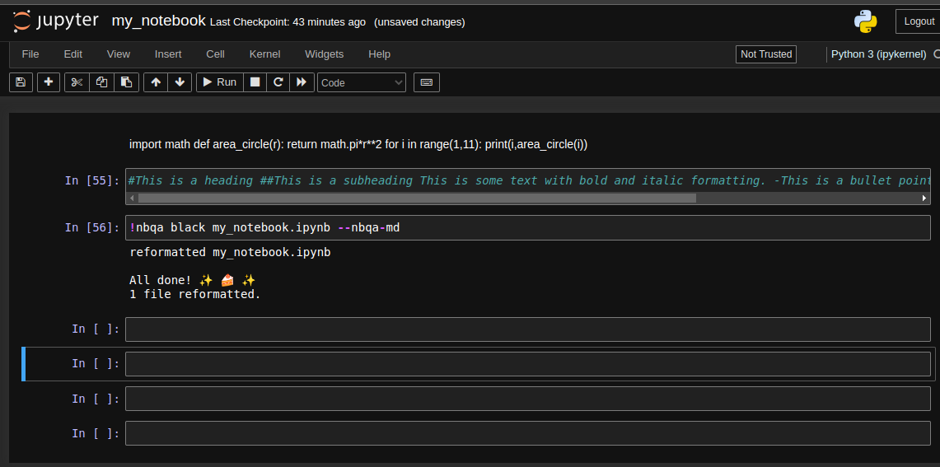

**After Formating**

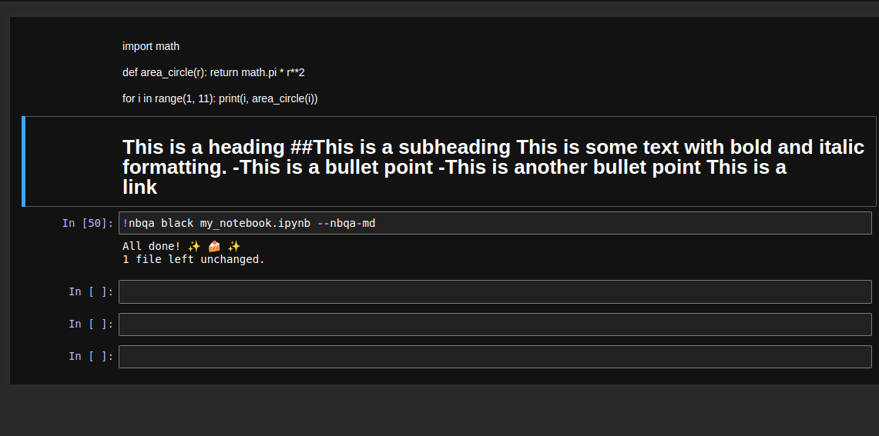

**2nd Solution**

**Using nbqa blacken-docs**

**Before Formating**

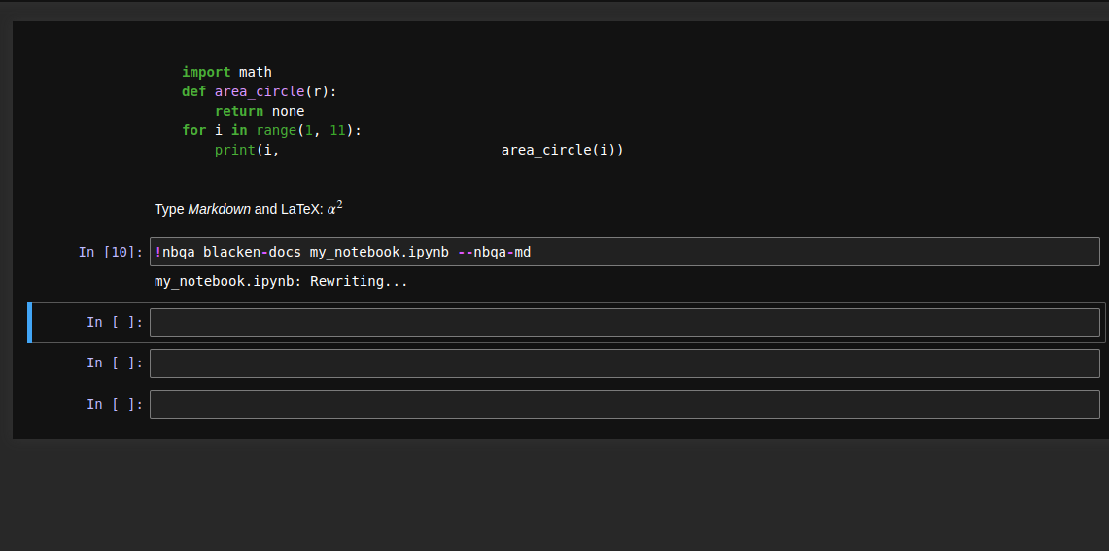

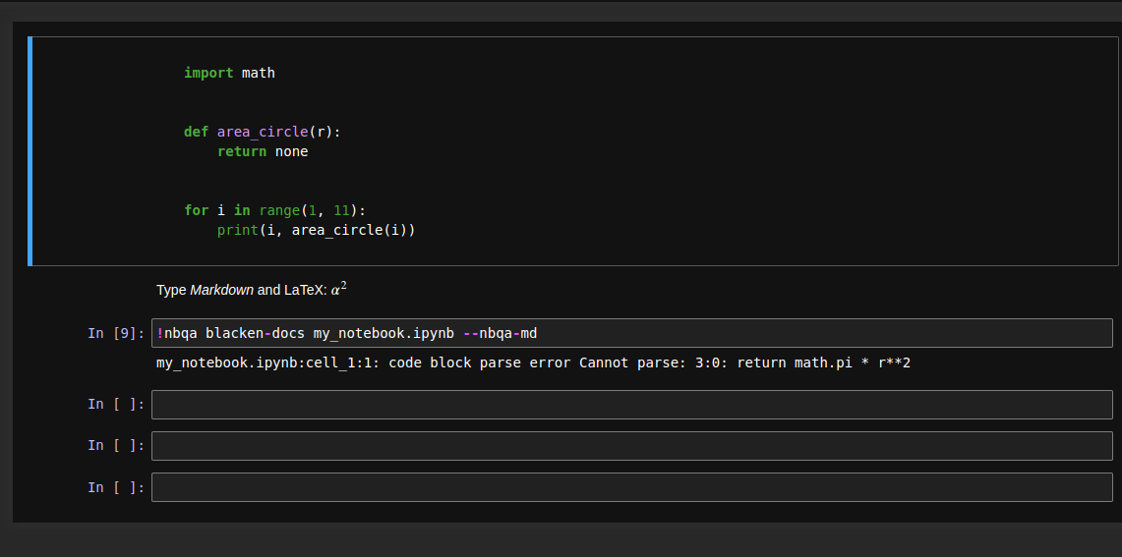**After Formating**